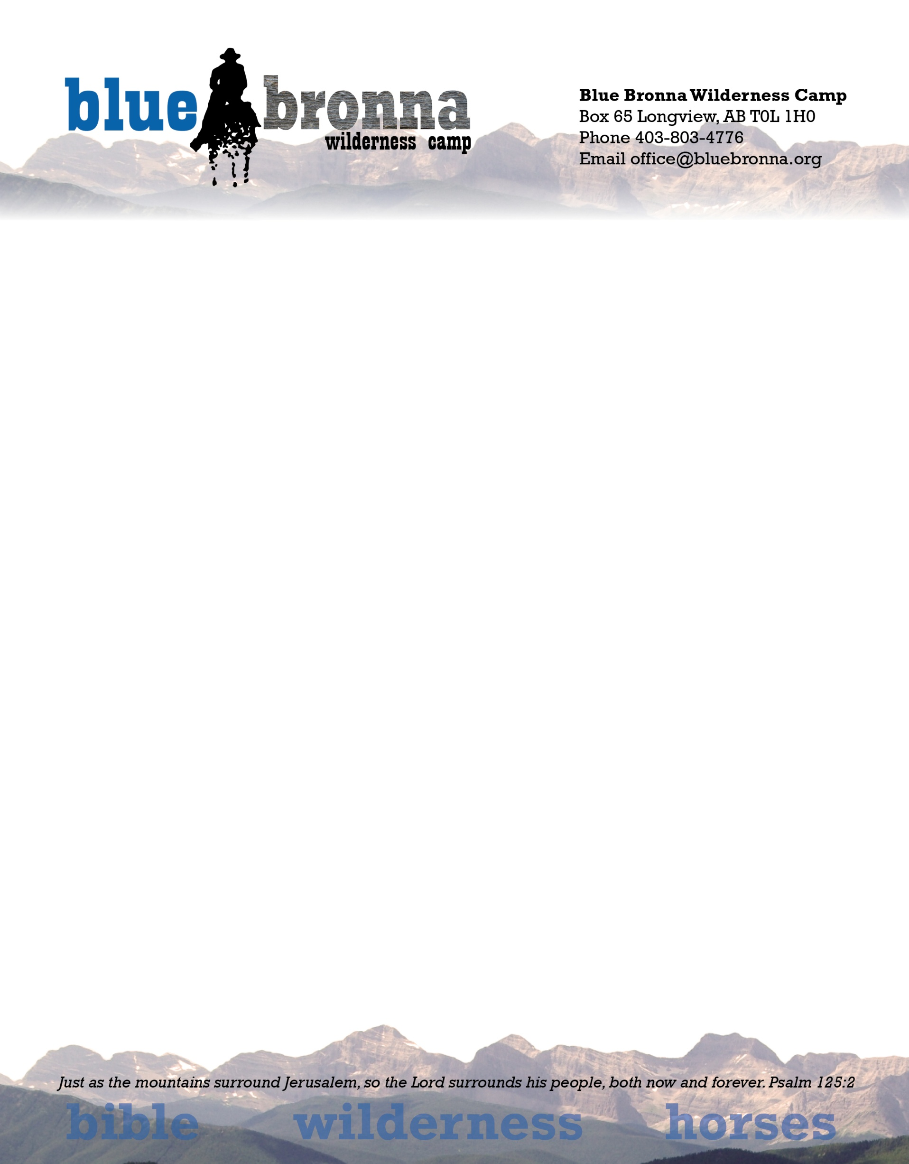

Greetings from Blue Bronna Wilderness Camp

We greatly appreciate your interest in the camp and in assisting us in the financial needs that we have on a monthly basis. Please fill out the information below and return it to us either by mail or email ([office@bluebronna.org](mailto:office@bluebronna.org))

Once we have logged your information into the ATB system, we will notify you that all is set up and the date that it will start.

Again thank you for helping us “Share Christ in A Wilderness Setting.”

Brent Ankrom

Camp Director

Re: Confirmation of Pre-Authorized Debit (PAD) Sign-up

Thank you for signing up for Pre-Authorized withdarwals for BLUE BRONNA WILDERNESS CAMP.

Your Name: ___________________________________________ Date: _________________

Your Address: ___________________________________________

1. Account Name: (Chequing, Savings) __ ______________________

2. Financial Institution (Name _________________________________

3. Transit Number: ________________________

4. Account Number: ________________________

5. Amount of Donation: ________________________

5. Frequency of Donation: ________________________

6. Donation Start Date: ________________________

7. Type of Pre-Authorized Debit: BUSINESS ACCOUNT _______ PERSONAL ACCOUNT _____

8, Statement with regard to Pre-notification

Your Pre- Authorized Debit Agreement may be cancelled provided notice is received 30 days before the next scheduled

PAD. If the details are correct, you do not need to do anything further and your Pre-Authorized Debits will be processed and start on the Withdrawal Start Date indicated above.

You have certain recourse rights if any debit does not comply with these terms. For example, you have the right to receive a reimbursement for any PAD that is not authorized or is not consistent with this PAD Agreement. To obtain more information on your recourse rights, contact your financial institution or visit www.payments.ca.”

PLEASE ALSO SEND US A VOID CHEQUE.